[DP-15] Adding and removing toppings from the pizza doesn´t give me all the time to add again toppings Created: 28/Apr/24 Updated: 28/Apr/24
Status: | To Do
Project: | Dominos Pizza

Type: | Bug | Priority: | Medium
Reporter: | Tomer Darmon | Assignee: | Unassigned
Environment: | - One plus 11 5G Android version : 14  - Samsung Galaxy S10 Android version 12

Attachments: | 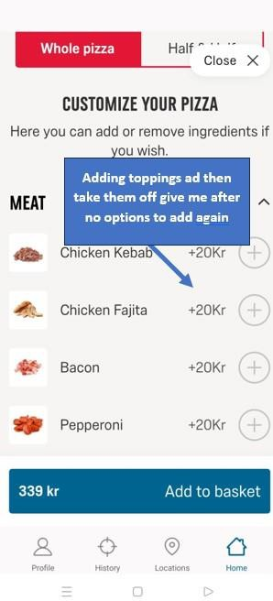
Severity: | S3 - Major

Description

Steps to Reproduce :
- Enter the Domino's Pizza app
- Go to the left top menu corner and choose “ORDER NOW”
- Choose one of the pizza´s that you are interested
- Choose the “MEAT” option or any other options
- Add a few toppings on the right side plus button from the list and then removed them
- Try to add again from the toppings
Actual Result : The plus buttons become grey, and you can´t press them to choose toppings options
Expected Result : I would expect that I would be able to add toppings again after removing them

30

